
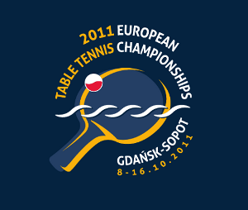
2011 EUROPEAN CHAMPIONSHIPS
Gdansk, Poland (8. – 16. October 2011)

STATEMENT

Association:
Contact person:
Contact phone:
Contact mail:

1.)
We understand and accept the conditions of the Championships and confirm that we are prepared to compete against all other teams and individual participants.

2.)
We confirm that all players entered to the championships through our association respect, accept and comply the current Anti-Doping rules by WADA/NADA which came into effect as of January 1st 2010.

Date:
Signature
Printed name
Position

Please return the statement to arrive to the ETTU Secretariat on or before
September 1st, 2011, either by e-mail or by fax.

ETTU, 37 Esplanade de la Moselle
L-6637 WASSERBILLIG, Luxembourg
Fax: +352 22 30 60

E-mail: ettu@pt.lu

