
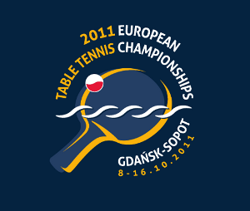
2011 EUROPEAN CHAMPIONSHIPS
Gdansk, Poland (8. – 16. October 2011)

Final Entries for Event 3 – Men’s Singles Championships

Association:
Contact person:
Contact phone:
Contact mail:

Names of players
No | Last name | First names | Date of birth
1
2
3
4
5
6

The order of this list will be used in the seeding of entries from your Association, in accordance with ITTF Regulation 3.6.3.2

Date:
Signature
Printed name
Position

Please return the entry form to the European Table Tennis Union to arrive not later than September 1st, 2011, either by e-mail or by fax. Eventual changes in the individual Entries will only be accepted up to the September 30, 2011. We remind that late entries will not be accepted.

ETTU, 37 Esplanade de la Moselle
L-6637 WASSERBILLIG
Luxembourg
Fax: +352 22 30 60
E-mail: ettu@pt.lu

