
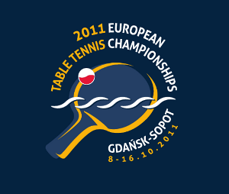
2011 EUROPEAN CHAMPIONSHIPS
Gdansk, Poland (8. – 16. October 2011)

Final Entries for Event 1 – Men’s Team Championships

Association:
Contact person:
Contact phone:
Contact mail:

Names of players
No | Last name | First names
1
2
3
4
5

Name of Team Captain (whether included in the list above or not)
No | Last name | First names
1

Date:
Signature
Printed name
Position

Please return the entry form to the European Table Tennis Union to arrive not later than September 1st, 2011, either by e-mail or by fax. We remind that late entries will not be accepted and changes of the nominations will only be accepted up to and including September 30, 2011.

ETTU, 37 Esplanade de la Moselle
L-6637 WASSERBILLIG
Luxembourg
Fax: +352 22 30 60
E-mail: ettu@pt.lu

