
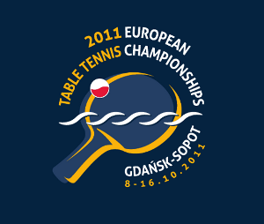
2011 EUROPEAN CHAMPIONSHIPS
Gdansk, Poland (8. – 16. October 2011)

ETTU CONGRESS
Monday, 10th of October 2011
09:30 a.m. (Novotel Marina Hotel)

Association:
Contact person:
Contact phone:
Contact mail:

Delegates
No | Last name | First names
1
2

Date:
Signature
Printed name
Position

Please return the entry form to the European Table Tennis Union to arrive not later than 1st of September 2011, either by e-mail or by fax.

ETTU, 37 Esplanade de la Moselle
L-6637 WASSERBILLIG, Luxembourg
Fax: +352 22 30 60
E-mail: ettu@pt.lu

