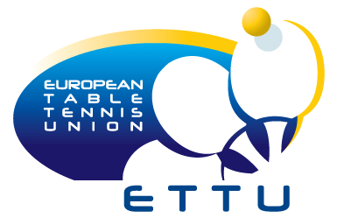
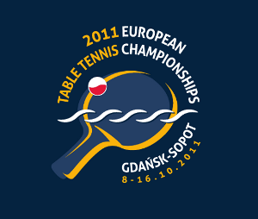
2011 EUROPEAN CHAMPIONSHIPS
Gdansk, Poland (8. – 16. October 2011)

Entry Fees according to the ETTU regulations

Association:
Contact person:
Contact phone:
Contact mail:

No | Event | Entry Fee € | Num. of Entries | Total €
1 | Men's Team | 35
2 | Women's Team | 35
3 | Men's Singles | 10
4 | Women's Singles | 10
5 | Men's Doubles | 20
6 | Women's Doubles | 20
 |  |  | Total €:

To be paid to Organising Association (see bank account in the Bulletin) not later than
September 25th, 2011. Please indicate your country code and subject at the bank transfer!

Date:
Signature
Printed name
Position

Please return to European Table Tennis Union to arrive not later than September 1st, 2011.

ETTU, 37 Esplanade de la Moselle
L-6637 WASSERBILLIG
Luxembourg
Fax: +352 22 30 60
E-mail: ettu@pt.lu

