
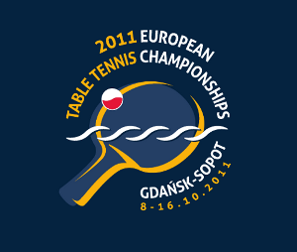
2011 EUROPEAN CHAMPIONSHIPS
Gdansk, Poland (8. – 16. October 2011)

Preliminary Entry Form

Association:
Contact person:
Contact phone:
Contact mail:

Competition team:

Event | Participates | Number of players
Men's Team | Yes No
Men's Singles | Yes No
Women's Team | Yes No
Women's Singles | Yes No
Men's Doubles | Yes No
Women's Doubles | Yes No

Number of people
Coach / Medical / Team leader:

Total number of people
Total number of rooms | SR
Total number of rooms | DR
Date:
Signature
Printed name
Position

Please return the preliminary entry form to arrive to the ETTU Secretariat on or before July 30th, 2011 either by e-mail or by fax.

ETTU, 37 Esplanade de la Moselle
L-6637 WASSERBILLIG, Luxembourg
Fax: +352 22 30 60

E-mail: ettu@pt.lu

