54th European Table Tennis Youth Championships
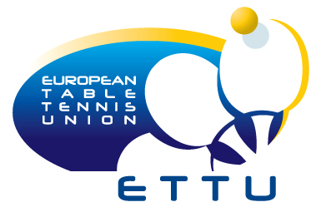
15. – 24. July 2011, Kazan (RUS)
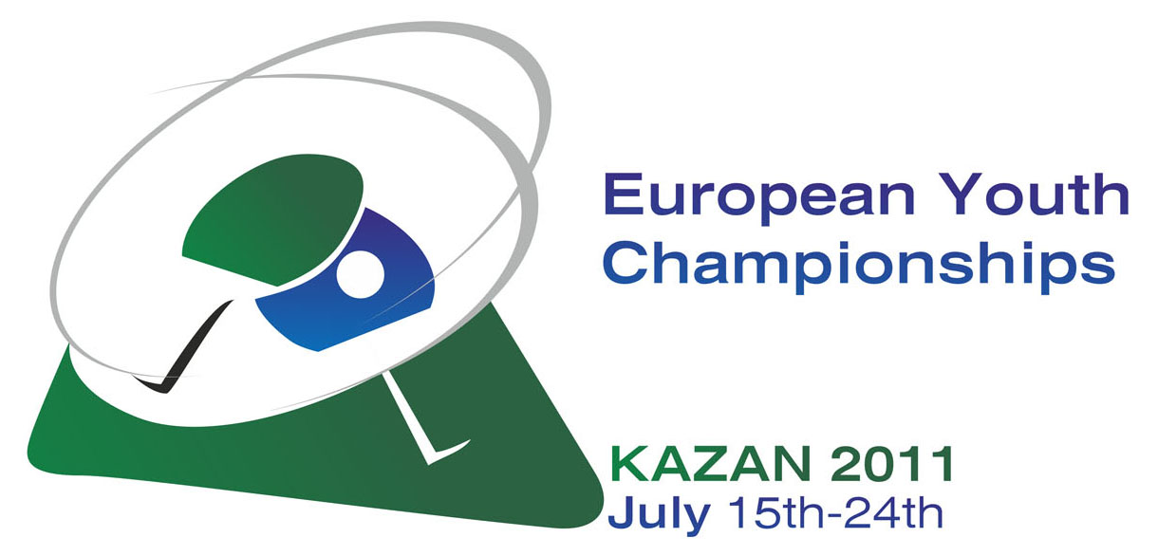

S T A T E M E N T

"We understand and accept the conditions of the Championships and confirm that we are prepared to compete against all other teams and individuals participating."

Association: ..................................................................................................

Signed by: ............................................................................................
Name and Position in Association

..................................
Signature

Please return this form not later than 31st of May 2011.

Address: ETTU Secretariat, 37, Esplanade de la Moselle L-6637,Wasserbillig, Luxembourg
e-mail: ettu@pt.lu

PLEASE NOTE THAT ALL DOCUMENTS HAVE TO BE RETUNRED BY EMAIL IN ORDER TO BE ACCEPTED.

