54th European Table Tennis Youth Championships
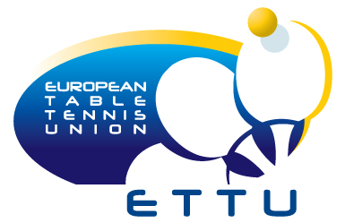
15. – 24. July 2011, Kazan (RUS)
 ENTRY FORM:

The Table Tennis Association of | COUNTRY | enters the following teams:

Pair | Cadet Boys´ Doubles
Pair | Player A | Player B
1
2
3
4

Pair | Cadet Girls´ Doubles
Pair | Player A | Player B
1
2
3
4

Pair | Cadet Mixed Doubles
Pair | Boy | Girl
1
2
3
4
5
6

CLOSING DATE: 31st of May 2011

To be returned to the ETTU Secretariat (ettu@pt.lu) on or before 31st of May 2011.

Signed by:
 | (Family Name) | (Given Name)
Position in Association:
Signature:

