54th European Table Tennis Youth Championships
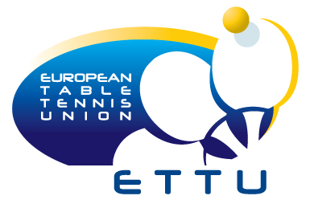
15. – 24. July 2011, Kazan (RUS)
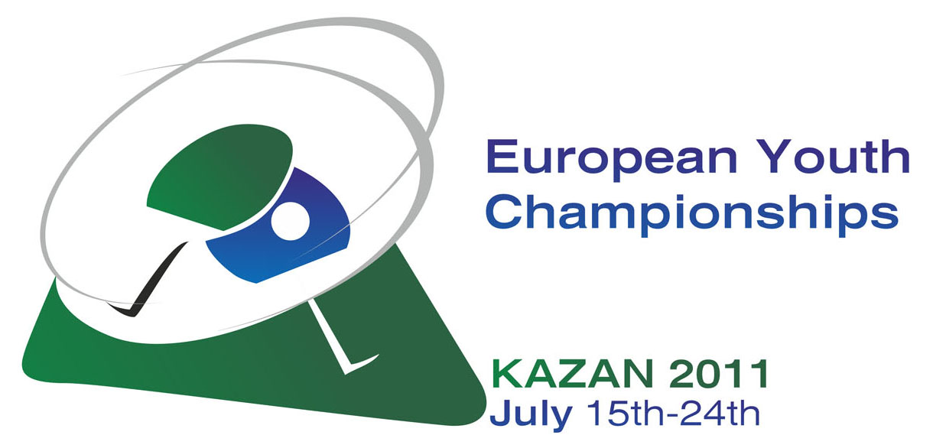

Booking of Accommodation

The Table Tennis Association ...............................................................................
We prefer our delegation being accommodated in:

No. of single rooms | No. of double rooms | No. of triple rooms

Notice: Please take note that the number of single rooms is limited.

The hospitality rate for those who are not entitled for free hospitality is in:

Triple room: 79 EUR/person/day

Double room: 89 EUR/person/day

Single room: 99 EUR/person/day

Please return this form not later than 2nd of May 2011

Name of the person in charge for accommodation in Kazan:
Mr. Farid Abdulganiyev (e-mail: g.davletshina@kazan2013.com)

with a copy to: ettu@pt.lu

