National Paralympic Committee of China

2010 ITTF Para-Table Tennis
China Open (Factor 20)
Beijing, China
December 2 - 8, 2010

Dear Table Tennis Friends,

On behalf of the organizing committee of 2010 ITTF Para-Table Tennis China Open (Factor 20), it is our great pleasure to invite all of you to Beijing from December 2nd to 8th 2010.

The Tournament will be held in China Administration of Sports for Persons with Disabilities, which is the biggest sports facility built exclusively for disabled sports in China.
OFFICE: No. 321 Tianbei Rd., Houshayu Town, Shunyi District, Beijing 101318
Phone: 86 10 8047 1874 Fax: 86 10 8047 137
Email: npcchina@cdpf.org.cn Web: www.caspd.org.cn

As the Tournament is going to be held right before 2010 Guangzhou Asia Para Games, we specially wish to invite athletes, coaches and staffs from all over Asia who are interested in the Tournament come to Beijing and compete as a warm up games for Guangzhou. Players from all over the world are welcome.

Enclosed herewith Tournament Fact Sheet, Preliminary Entry Form and Final Entry Form.

Please be advised, the Preliminary Entry Form must be returned to OC NO Later than September 30th.

We are ready to host you and provide you a wonderful hospitality while your stay in Beijing.

With kindest regards,

Sincerely yours,
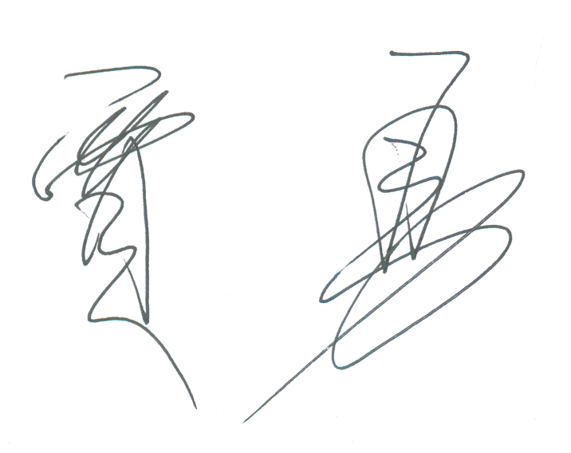
JIA Yong
President
National Paralympic Committee of China

GENERAL INFORMATION

- Organizer: National Paralympic Committee of China

- Sanctioned by: International Table Tennis Federation

- Factor: 20

- Venue: China Administration of Sports for Persons with Disabilities (CASPD)

- Accommodation: China Administration of Sports for Persons with Disabilities (Fully Accessible)

- Arrival and Departure:
Arrival: December 2nd, 2010
Practice & Classification: December 3rd, 2010
Competition: December 4th - 7th, 2010
Departure: December 8th, 2010

- Airport: Beijing Capital International Airport

- Transportation: Airport shuttle bus will be provided on Arrival and Departure day.

- Delegation ratio
The delegations are entitled to use the following allocation method:
- One (1) Chef de Mission plus;
- One (1) Medical Doctor plus;
- One (1) team official (i.e. coach, administrator, para-medical staff) for every three (3) athletes (rounded up) plus;
- One (1) team official for every two (2) athletes classified in the class 1, 2 and 6 sport classes (rounded up) plus;
Regular Team Officials, with the same functional ability as the athletes in the class 1-2 and 6 sports classes, may request one (1) additional team official to support them.

10. Equipment: Ball: Double Happiness or Double Fish; Table: Double Fish.

11. Uniforms: Each delegation should prepare uniform with Nationality and participant’s name on it in accordance with PTT clothing regulation.

12. Classification: Classification will be conducted before the competition start.

13. Prize: The top 3 players will be awarded gold, silver and bronze medals.

14. International Umpires: International umpires will be appointed by ITTF.

15. Entry Fee:
480 Euro (80 Euro/person/day) for each participant;
600 Euro (100 Euro/person/day) for additional staff (not included in the ratio)
This includes:
Accommodation (double room and full board) from Dec 2rd to 7th, 2010;
Local transportation (Beijing Capital International Airport to CASPD);
ITTF Capitation Fee;
Single Room: extra charge of 20 Euro/person/night;
Extra Night: 50 Euro/person/day with double room and full board;

16. Meals: Meals will be served from Lunch on Dec 2rd to breakfast on Dec 8th;

17. Insurance: Each NTTA or NPC is responsible for the appropriate insurance for accidents, health, property and liability of their team.

18. Visa: Please contact the Chinese Embassy/consulate in your country if you need visas to enter China.

19. Entry Deadlines:
September 30, 2010: First entry by number with 30% of entry fee (non-refundable);
October 29, 2010: Final entry by names including all details of team with the balance of entry fee;
Bank Detail:
Account Name : China Administration of Sports for the Persons with Disabilities
Agriculture Bank of China
No. 2, Fuqian Road, Shunyi District, Beijing, P.R. CHINA
Swift Code : ABOCCNBJ010
Account No.: 11-120101040019661

√All bank charges are on costs of participants’ expenses

20. Contact: Michael JIANG
Table Tennis Management Team
China Administration of Sports for Persons with Disabilities
Email: npcchina@cdpf.org.cn
Tel: +86 10 8047 1874 Fax: +86 10 8047 1937
Address: No. 321 Tianbei Rd., Houshayu Town, Shunyi District, Beijing 101318, China

