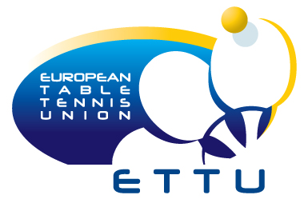

EUROKIDS CAMP
4 - 10 October 2010
SIERRA NEVADA - SPAIN


ETTU Youth and Development Department
July 2010

Supported by |  | Sponsored by
 |  | 

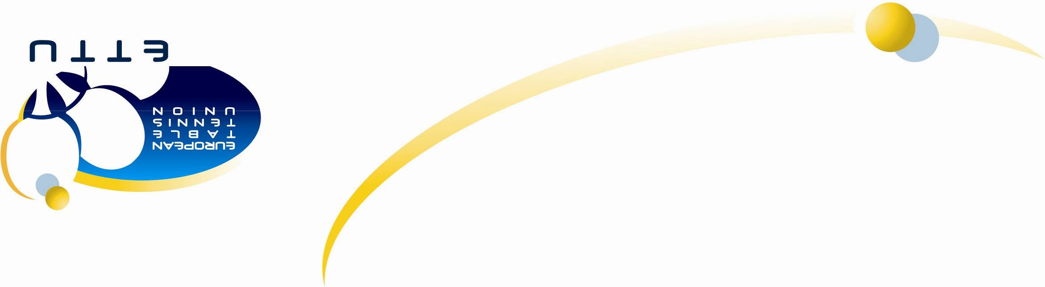
PROSPECTUS

HEAD COACH – Branka BATINIC (HRV) COORDINATOR – Lila de SOYSA (CH)
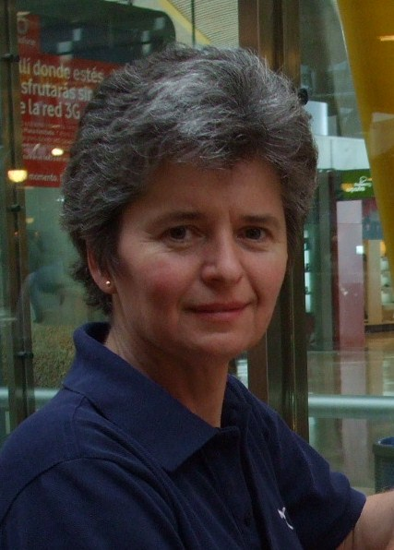  e-mail: branka.batinic@gmail.com |  | 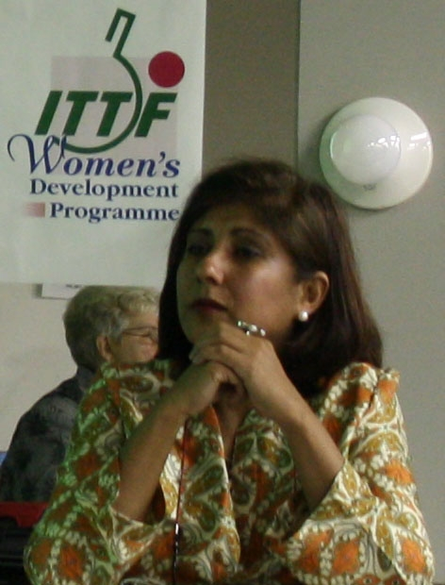  e-mail: lila_de_soysa@bluewin.ch

ORGANISER: ETTU in cooperation with the Spanish Table Tennis Association, supported by the ITTF.

Participation Criteria
All European National Associations may nominate two players, one girl and one boy, born 1998 or later and one accompanying coach. National Associations should nominate talented players, from whom future top performance may be expected.

DEADLINE FOR APPLICATIONS:
Associations shall send their entries using the attached “Entry and Travel form” no later than Tuesday 31st August 2010.

SCHEDULE 4 October: arrival day and meeting with coaches
5 - 9 October: training camp (with tournament)
10 October: departure day

VENUE Centro de Alto Rendimiento – Sierra Nevada
www.carsierranevada.com
Contact person: S. Maxhera (Max) – administracion@rfetm.com
 Office (+34) 91 547 7726

ADDRESS
Centro de Alto Rendimiento
Sierra Nevada
Monarchil C.P. 18196
Granada, Spain
 0034 958 48 20 o4
 Fax 0034 958 48 07 44

The High Performance Centre of Sierra Nevada (CAR) is located in southern Spain, in the municipality of Monachil, 31 km from Grenada. It is situated at an altitude of 2,320 m above sea level and is suitable for training in altitude.

ACCOMMODATION

You can be accommodated in single, double and triple rooms, at the CAR. Please visit their website for more information (www.carsierranevada.com).

FINANCIAL CONDITIONS

ETTU covers the accommodation on full board basis for complete teams and the expenses of the camp’s organization. However, a cost of 10 euros per participant per day will be charged to the participants. This can be paid directly on arrival to Lila de Soysa. An invoice will be sent to you in due course. Please ensure that you bring the exact sums with you.

TRANSPORT

ARRIVAL – DEPARTURES

The MOST convenient airport is the airport of Grenada. It is 31 Km from the CAR. You will have free pick-up from the Grenada airport. However, you may also use the Malaga airport which is about 1h away. If you need pick-up from there, there will be an additional cost of approximately 12 euros per person (one way) and you may have to wait for others to arrive so that you can use the same transport.

For those coming with their own vehicle, there will be free parking at the Training Centre.

VISAS

If your delegation needs a visa for Spain, please get in touch with Max, at the Spanish Federation at: administracion@rfetm.com, Office (+34) 91 547 7726,

MEETING & SEMINAR FOR COACHES

A meeting with the coaches and the Head Coach will be held on the 4th at 8 pm.
A day seminar for the participating coaches will be held during the camp (day and time to be decided), led by Steen Hansen, Technical Director of the Spanish TTA.

EXTRA ACTIVITIES

Bring your swimsuits. You may be able to use the swimming pool at certain times. Don’t forget your outdoor running shoes.

Free Internet and wi-fi are available in some rooms and some areas of the CAR.

We will try to organise a trip to Grenada and a visit of the Alhambra, at extra cost. Visit www.sierranevada.es for more info about the region.

MISCELLANEOUS

If any participants have allergies, health issues or special dietary restrictions that we should be aware of, please let us know well in advance so that we can take the necessary measures.

Please ensure that your teams have their own insurance coverage.

YOU ARE A EUROKID – YOU ARE A CHAMPION

See you in Spain!

Lila de Soysa – ETTU Olympic Project Manager
lila_de_soysa@bluewin.ch

