
OPŠTINA
VRNJAČKA BANJA STONOTENISKI SAVEZ SRBIJE
• • • •
MUNICIPALITY OF TABLE TENNIS ASSOCIATION OF SERBIA
VRNJACKA BANJA

P R O S P E C T U S

SERBIAN YOUTH OPEN '010
Serbian Junior & Cadet Open

23. - 26. September 2010.

Vrnjacka banja, serbia

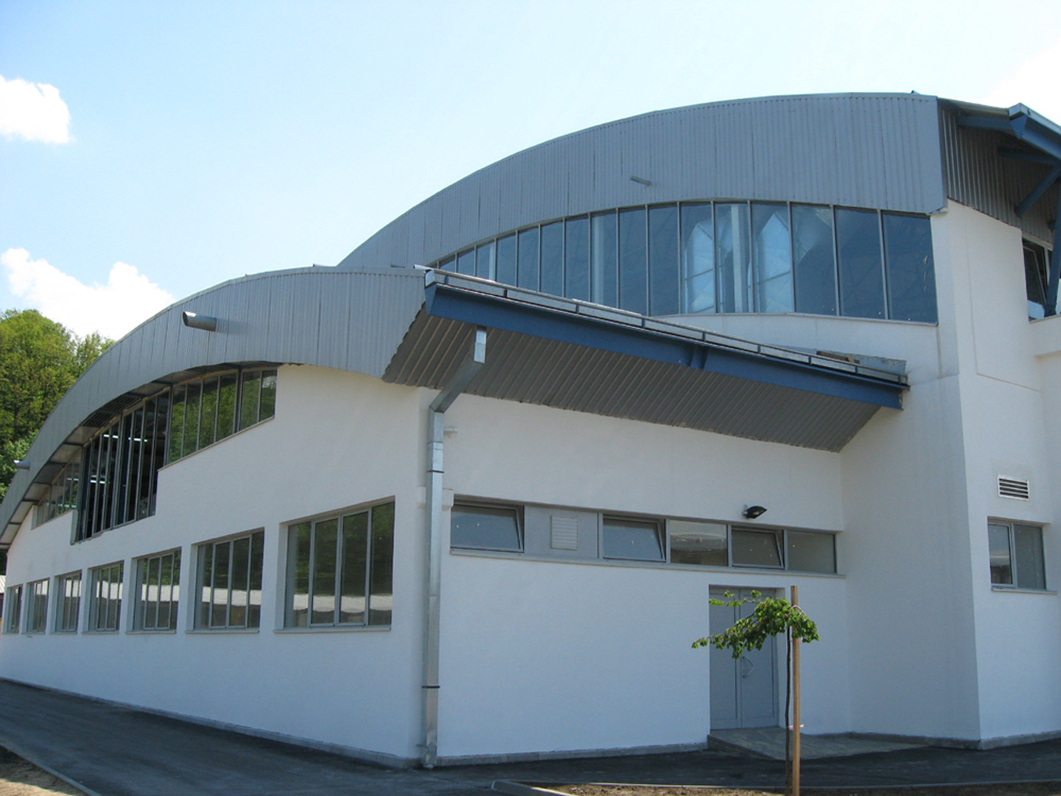

Sportska hala „Vlade Divac“ - Vrnjačka Banja
Sports Hall „Vlade Divac“ - Vrnjačka Banja
P R O S P E C T U S
of
SERBIAN YOUTH OPEN '010

- Competition dates: 23. SEPT 2010. / 26. SEPT 2010.

- Organizer: TABLE TENNIS ASSOCIATION OF SERBIA
Str. Strahinjica Bana 73/a 11000 Belgrade
Tel: + 381 11 2631 375
Fax: + 381 11 2625 048
E-mail: stss@sbb.rs

MUNICIPALITY OF VRNJACKA BANJA
Str. Krusevacka 17. 36210 Vrnjacka Banja
Tel: + 381 36 612 627
Fax: + 381 36 612 624
E-mai: vrnjci_spa@ptt.rs

3. a/ Tournament Director: STEVANOVIC Dusan
Mob. Tel: + 381 63 245 414

b/ Executive Director: ZIVIC Jovan
Mob.Tel: + 381 65 97000 12

c/ Event Manager: TRPKOVSKI Milorad
Mob.Tel: + 381 65 97000 13

- Venue: SPORTSKA HALA „Vlade Divac“

- Events:

1. Junior Boys Team 7. Cadet Boys Team
2. Junior Girls Team 8. Cadet Girls Team
3. Junior Boys Singles 9. Cadet Boys Singles
4. Junior Girls Singles 10. Cadet Girls Singles
5. Junior Boys Doubles 11. Cadet Boys Doubles
6. Junior Girls Doubles 12. Cadet Girls Doubles

- Eligibility:

- Players born on or after 1st January 1992 may participate for Juniors events
- Players born on or after 1st January 1995 may participate for Cadets events

- System of play:

TEAM EVENTS

Team events will be played in two stges, groups in the first stage and KO in the second stage.

- Junior team format: A-X, B-Y, C-Z, A-Y, B-X (3 players minimum)
- Cadet team format: A-X, B-Y, Double, A-Y, B-X

SINGLES EVENTS

The competition in the JBS, JGS, CBS and CGS will be played in two stages defined as: First Stage and Main Draw.

In the First Stage participants will be divided generally in groups of 4 or 3 players with priority given to groups of 4 players. As an exception to this rule, the Event Manager can authorize the division of the players in groups of 4 and 5 players (for example if the Tournament includes only singles and doubles events but not teams); in this case, again the groups of 4 players will be the priority.

Two players will advance from each group to the Main Draw.

If the number of entries is larger than 64, the higher 8 or 16 ranked players taking part in the event will advance directly to the Main Draw and also if the number of entries is very low, lucky losers can also complete in the Main Draw.

The Event Manager, in agreement with the Tournament Director is
the sole responsible person for all matter concerning the system of play.

Competition in the First Stage will be best of 5 games while the Main Draw will feature matches best of 7 games.

DOUBLES EVENTS

For the doubles, the system of play will be knock-out from the qualification stages throughout the finals. All matches best of 5 games.

8. Seeding list: According to the last available ITTF/ETTU Junior/Cadet Ranking list

9. Jury Meeting: Will be held on 22. September 2010 at 20 h in Sports Hall „Vlade Divac“

10. Equipment: Tables: DONIC WC
Practice hall tables: DONIC WC
Balls: Nittaku premium ***
Floor: wooden floor

11. Hospitality: All included: Accomodation, meals and
transporation (hotel-Hall-hotel)

OPTION 1:
Association which enter 4 teams
50 EURO (double room)/ per person per day
55 EURO (single room)/ per person per day

OPTION 2:
Association which enter 3 teams
55 EURO (double room)/ per person per day
60 EURO (single room)/ per person per day

OPTION 3:
Association which enter 2 teams
60 EURO (double room)/ per person per day
70 EURO (single room)/ per person per day

OPTION 4:
Association which enter 1 team
65 EURO (double room)/ per person per day
75 EURO (single room)/ per person per day

12. Schedule: Will be confirmed through the TTAS web site:
www.stss.rs

13. Entries: The entries must be sent to the Table Tennis Association of Serbia, preferably by E-mail:
stss@sbb.rs

14. Deadlines: Preliminary Entry Form 23. AUG 2010
Final Entry Form 15. SEPT 2010
Traveling Details 20. SEPT 2010
Changes in nominations 21. SEPT 2010

15. Visas: If you need a visa, please contact the TTA of Serbia
as soon as possible, so we can assist you with the visa process.

16. Bank details:

Itermediary 56a: DEUTDEFF (DEUTSCHE BANK AG, FRANKFURT)
Account No.57a: 936528900
VBUBRS22 (Vojvodjanska banka Novi Sad, SRB)
Beneficiary custtomer 59: RS35 3550 0000 0200 4193 94 (IBAN CODE)
STONOTENISKI SAVEZ SRBIJE
BEOGRAD SRBIJA

MUNICIPALITY OF STONOTENISKI SAVEZ
VRNJACKA BANJA SRBIJE

President, President,
SEIZOVIC Zoran KALINIC Zoran

